Forest Methodist Church

December Newsletter



Serve Learn Share Praise
Methodist Church 
Bailiwick of Guernsey
Minister:
Rev’d Jacky Cottrell
The Manse, 2, Le Chene D’Mont, Le Chene,
Forest, GY8 0AL Tel: 234105
Email: revdcottrell@gmail.com

Festive greetings dear Friends,

Well, here we are at the most wonderful time of the year! We are now stepping into the season we call in church Advent. This is the start of the cycle of bible reading we follow each Sunday. The name comes from Latin adventus 'coming; arrival', translating the Greek Parousia from the New Testament.
Advent is a time of watching and waiting. We count down on our advent calendars and eat our chocolates, or cheese or wear new socks; there are many varieties of Advent calendars available now. I wonder what is the most bizarre you have heard of.
In church we count down from the darkness by adding more candles to our Advent wreath, thanks to Debbie for preparing it. In the bible we read ‘The true light, which gives light to everyone, was coming into the world. He was in the world, and the world was made through him, yet the world did not know him’ John chapter 1 verse 9 &10. So, although all around us we see preparations and discussions of Christmas, it is up to us all to spread the good news, put Christ into Christmas, for those who have not yet met with him. Do invite others to our special Christmas gatherings, details inside.
Also please do come and join in, when possible, our informal singing practices 7.30-8.30 Monday evenings. We are planning to bless our neighbourhood and sing in local pubs on the evening of 12th Dec. Even if you have not come to practice do come join in this festive outreach. Also, the singing group will enhance the Carol service on 21st Dec. So, lots of fun, eating, singing, and celebrating to come!
Although we are not there yet, a very Merry Christmas to you all and all your loved ones, when we get there!
Advent blessings, Revd Jacky.

"Tumaini prayer breakfast at Les Adams Methodist Church will pray and eat at 9 a.m on the 29th Nov. All are welcome.
Our last Prayer Breakfast will be 27th Dec.

Thank you to all who have joined us and prayed for the incredible people of the Tumaini project in Tanzania, during 2025.

New for 2026 we will pray at the new Tumaini pop-up shop located in town at the Picquet House. Starting 8a.m. 3rd Jan ahead of opening at 9a.m. dedicating the place to the Lord Jesus.

All are welcome! Every prayer counts."

SOCKTOBER
Huge thanks for all the socks you generously gave during Oct. A whooping 196 pairs were given between my 3 churches. Half went to St. Julian House, (picture below show the guys happily receiving them.) The other half went to At home in Guernsey (logo below); they are a charity that supports the homeless, emotionally and practically, and those at risk of homelessness on the island. All making a huge difference.

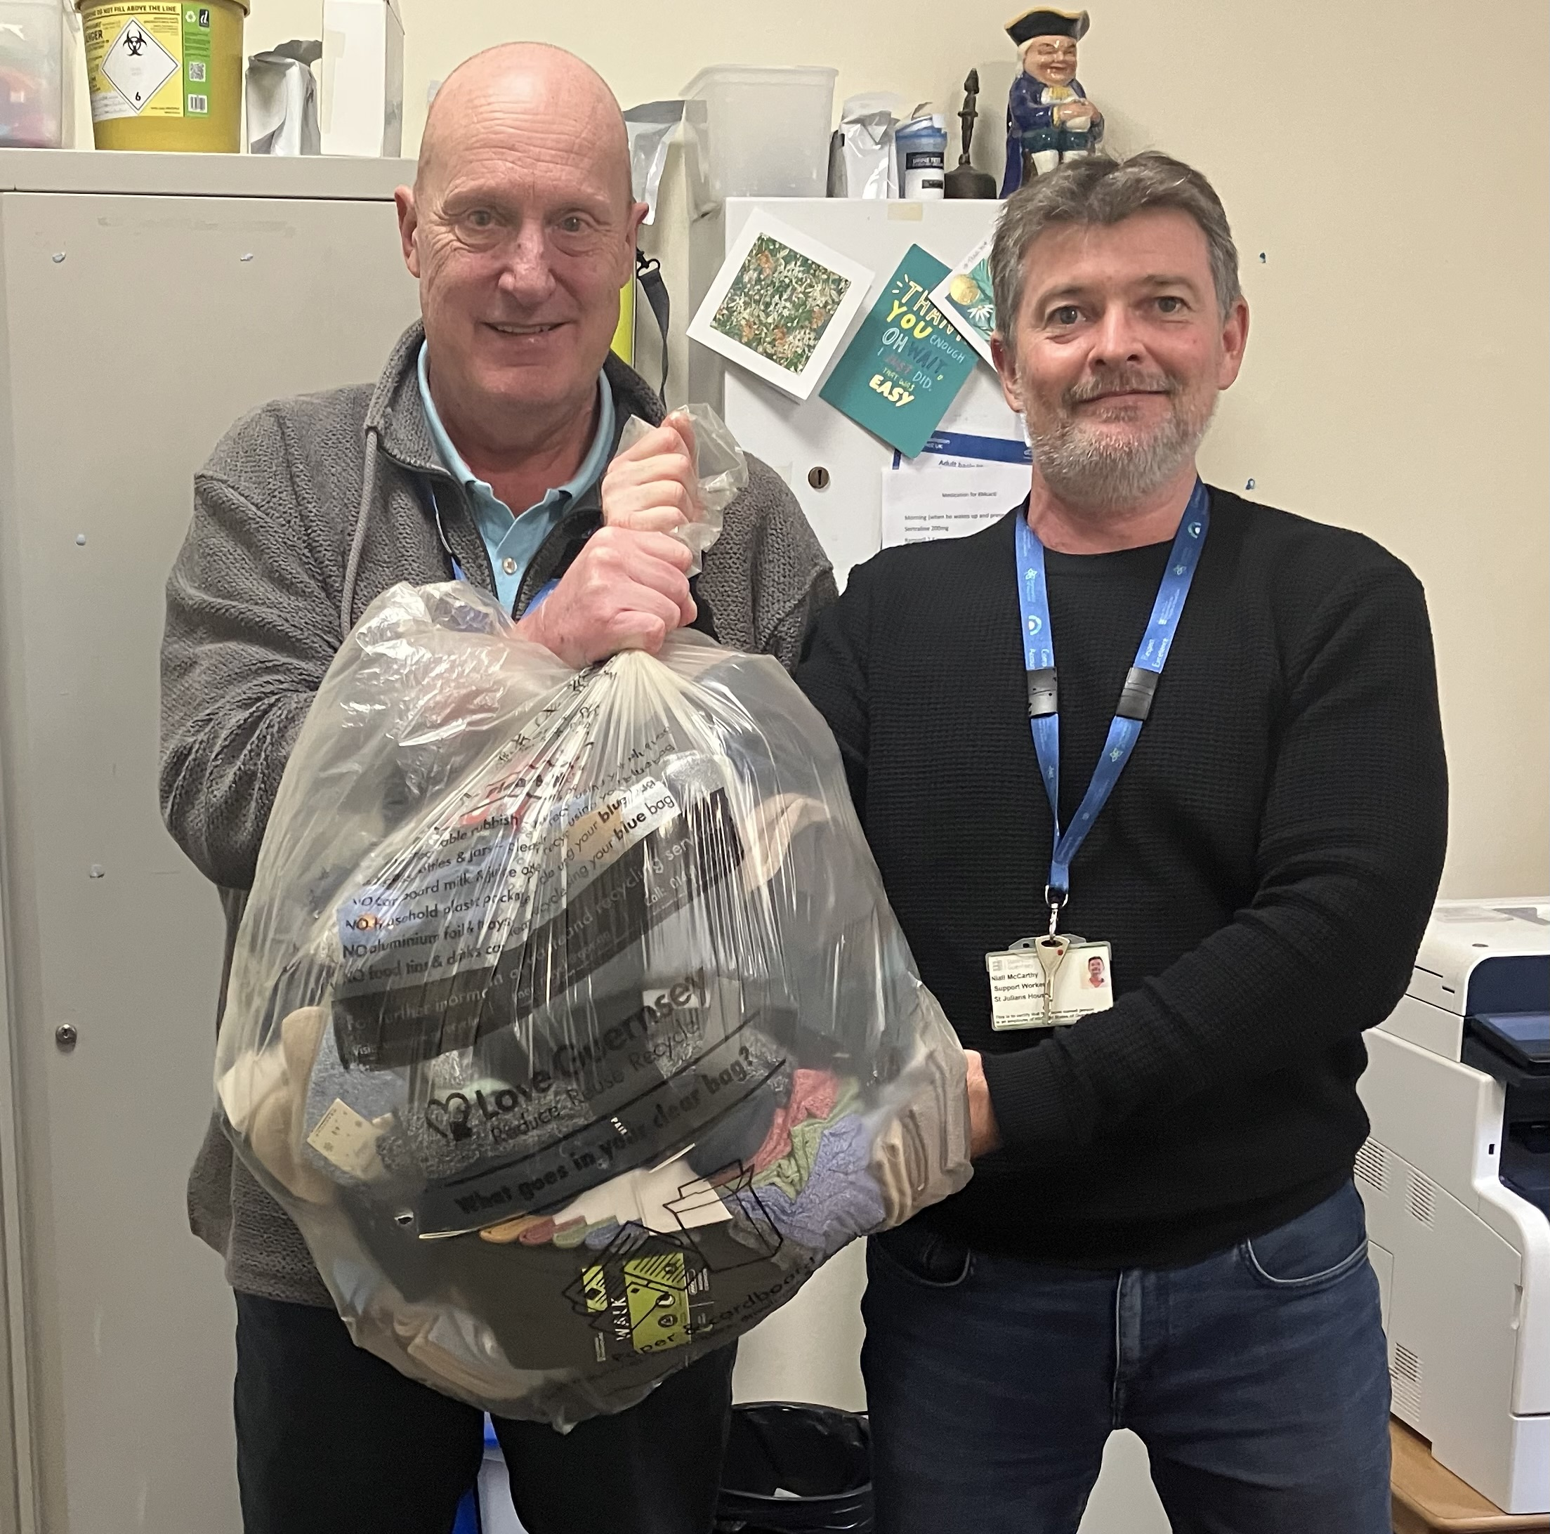







Carols
We all love singing carols, and the season is nearly upon us!
Sarah K and Peter invite everyone, to come along to a few informal practices, to blow off the cobwebs, polish up our skills, (whatever level they are) all welcome! We are planning to go to local pubs on the eve of 12th Dec, taking festive cheer and handing out Cindy’s crochet hearts with a message of Christmas and welcome to our Christmas services. Then of course we can sing with gusto at our Carol service on 21st Dec.
Please come 7.30-8.30pm on 1st, 8th, 15th Dec,
The St. Paul’s Christmas Fair is being held on Saturday, 6th December from 2.00 p.m. to 4.00 p.m.
There will be stalls selling cakes, books, plants, Christmas items, a Christmas present stall, a lucky dip and a raffle.
Refreshments will be available and the proceeds are going to the church and Parkinson’s, Guernsey.
There is parking at church and in the Vale Primary school next door.


Apology
We printed a poem in our Sept edition that has come to light was not correct.
We fully apologise to the writer Sharyn Owen for this unintentional mistake.
Please see below the original version of her poem 'Knitting'. It appears in her book 'Wise Child' published by Enigma Publishing in 2025. It is not widely available yet but she hopes to put it onto Amazon soon. Perhaps we can all look for it.
Knitting
We’re a loose-knit family;
Mostly plain, with a few pearls.
We have our castings on
and our castings-off.

We are open-weave, spinners of yarns -
Embroiderers of the truth.
We pull strings for good causes.
Unkindness needles us.

We’re granny and reef knots.
Occasionally we drop a stitch
but we keep to the pattern
and we never pass a slipped-stitch over.

Sharyn Owen

(When passing on to Michelle any contributions, please check accuracy and have permissions, thank you.)

Flower Rota
Is there anyone who would like to join the weekly rota to place flowers on the altar at the morning Service?
The flowers remain there for the Evening Service and then are given to anyone at our church who would benefit from a gift of flowers.
If you are interested, please get in touch with Sarah Plumley or Beth Orr.

Preaching & Duty Stewart Schedule
God & Marmalade is at 8.45am
Date | AM Preacher | Duty Steward
7th December | Jacky Cottrell (HC) | Sarah
14th December (11am) | Jacky Cottrell | Rosemary
21st December | Jacky Cotrrell | Beth
25th December | 10.30am at Les Adams | N/A
28th December | Jacky Cottrell | Sarah

Evening Service is at 6pm
Date | PM Preacher | Duty Steward
7th December | Keith Le Parmentier | Pam
14th December | N/A | N/A
21st December | Jacky Cottrell | Sarah
24th December  Christmas Eve | 6.00pm Christmas (HC) | Beth
25th December  Christmas Day | N/A | N/A
28th December | Fellowship | Beth

Flower Rota
Date
7th December | Margery Cartmell
14th December | Judy Wade
21st December | Jenny Falla
28th December | Jenny Falla

G & M Breakfast Rota
Date | Breakfast | Setting Up | Cloth Wash
7th December | Debbie D/Rosemary | Leon | Margaret
14th December | Catering | All | Sarah
21st December | Sarah | Steve/Jan | Jenny
24th December Christmas Eve | N/A | N/A | N/A
25th December Christmas Day | N/A | N/A | N/A
28th December | Sandra/Ian  Jenny | Michelle G | Beth

Welcome Steward Rota
DATE | AM | PM
7th December | Andrea | Beth
14th December | Sandra | N/A
21st December | Andrea | Brian
24th December Christmas Eve | N/A | Beth
25th December Christmas Day | N/A | N/A
28th December | Brian | Beth

With grateful thanks to all who give their time to the service of the church

Notices/articles for next month let Michelle know by Wed 26th November
Tel no: 01481 266019/07781 166019 email: mgilson_gsy@hotmail.com

PARKING FOR THE AIRPORT at Forest Methodist
We are letting out five spaces, on a first come, first served basis, at a cost of £20 per week or part thereof. These parking spaces will be at the back of the top rear car park and will be delineated.
THIS WILL BE ENTIRELY AT CAR OWNERS RISK
To reserve a space please email rosemary.willey@gmail.com and cc to carolejehan1972@gmail.com.
You will need to provide your car number, dates required and a contact telephone number. Please can you display your Christian name on your dashboard when leaving the vehicle.
It should be noted that on the rare occasions when the car park is full, I.e. funerals, access to your vehicle may be temporarily delayed.
THERE IS TO BE NO UNAUTHORISED USE OF PARKING SPACES WITHOUT FOLLOWING THE ABOVE GUIDELINES.

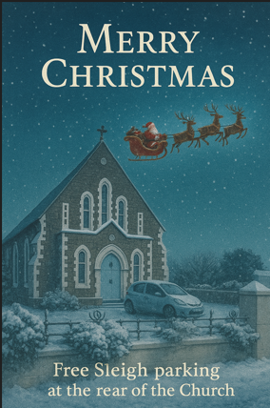
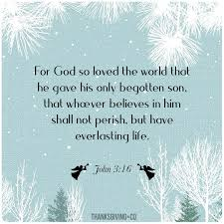

MEET & EAT
Meet & Eat takes a break during December but look forward to seeing everyone in the New Year.

FOREST LADIES GROUP.
Are meeting at the Church on
Thursday 11th December at 2.00pm
For CHRISTMAS CELEBRATIONS
(Including Secret Santa up to £10 in value)
Ladies, come and join us for Fellowship & Fun
Warm welcome to all Ladies to come and join us
Further details from Beth Tel: 263564 / Mob: 07781

The Sark born artist Rosie Guille has donated some of her beautiful calendars for our Shelter Box charity.
They are available to anyone who would like to make a donation and will be on display in the Welcome Area.

GIFTED

Is the title of the Methodist churches campaign this Advent and Christmas. If you would like to receive an email each week from them, go to methodist.org.uk to sign up. Here are some of the resources to help you through Advent. If you would like to gather and reflect on them as a group, I would be available on a Saturday morning, in church, please let me know. Or you can see all the resources on the website and maybe gather a few friends to share at home.

PRAYER for each week- Gift-giving God, in this season of Advent, help us to give and receive peace. Shape us into people who bring hope, not just at Christmas, but every day. Unwrap what’s hidden or held back in us, so that we can shine with your light. Amen.

Week 1. READ Matthew 24:36–44…. Jesus talks about how we don’t know when he will return. He compares it to a surprise visit, a bit like a thief in the night. His message is clear: stay awake, stay ready. Keep living!

REFLECT Where do you notice kindness or calmness in your community?
What small thing could you do this week to bring a bit more peace to where
you live? When have you felt like a gift to someone else? What’s one thing you could do this Advent to help someone else feel loved?

Week 2. READ Matthew 3:1–12 ….John the Baptist with a strong message of change, even to powerful people.

REFLECT Can you think of someone who has used their position to help others? “Repent” means to change your thinking. Is there a habit or attitude you’d like to leave behind this Advent? Galatians 5 talks about “the fruit of the Spirit”: love, joy, peace, patience, kindness, generosity, faithfulness, gentleness and self-control. Which of these have you seen growing in your life recently? What would it look like for our church to be a real blessing in the community this December?

Week 3 READ Matthew 11:2-11….John is in prison and questioning if Jesus is the one they waited for?

REFLECT Have you ever felt unsure about your faith? What helps you hold on to hope in difficult times? Have you ever received a word of hope or encouragement from someone else, that really impacted you? How might you offer the gift of hope to someone this week?

Week 4 READ Matthew 1:18-25 … Joseph discovers Mary is with child and this calls for much trust and courage on his part.

REFLECT Can you think of someone who showed you kindness at a challenging time? What helps you believe your life is a gift from God? Jesus means ‘God saves.’ Emmanuel means ‘God with us’. Which means most to you and why?

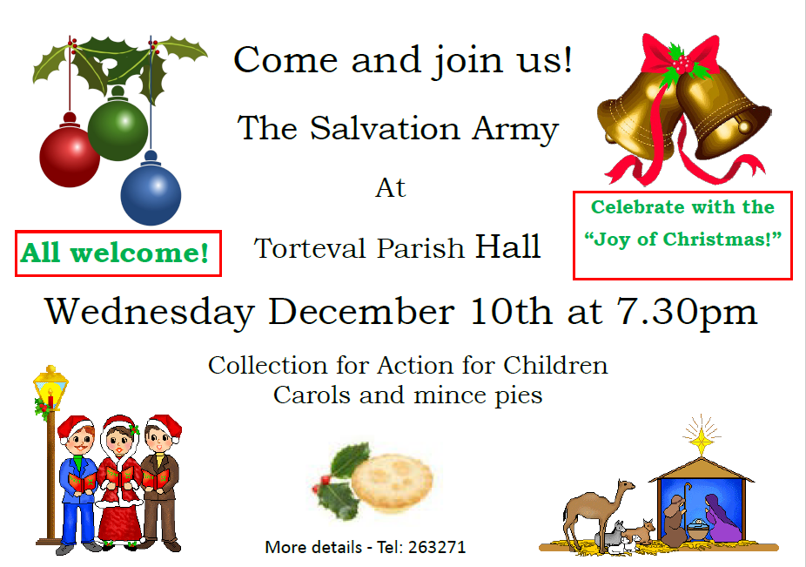

Christmas Worship
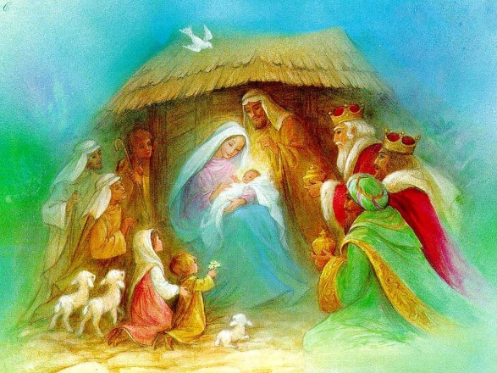
Sunday 14th December
at 11.00am
followed by lunch at 12.

Please sign up if you can come


Prayer Pages

IN YOUR PRAYERS
If you know of someone who would appreciate being on our prayer list, please ensure you have the person's permission before passing their name to Michelle.
Please pray for Ron Gould, Win De La Mare, Karen Harrison,
Rachel Meinke, Caroline Treharne, Joyce Baudains,
Margaret Boden-Heaume, Bob Cartmell,
Rev John Luff and his wife Carole,
Howard Ellis (Sandra’s son), Debbie Hobbs,
Colleen Ogier, Debbie Dorey,
Sarah’s grandson Edward
And Philip Salmon

Bailiwick of Guernsey Churches Prayer Cycle for 2025
Dec 07 United Reformed church, St Saviour / Mill Street Community Cafe
Dec 14 Capelles Methodist church / Pray for ministers and clergy and their families
Dec 21 Pray for those who will come to Christmas services (Day of prayer for migrants & asylum seekers)
Dec 24 CHRISTMAS EVE
Dec 25 CHRISTMAS DAY
Dec 26 ST STEPHEN, FIRST CHRISTIAN MARTYR St Stephen’s church
Dec 28 (Day of prayer for expectant mothers)

FACTOR 7
Please pray wherever you are: at home, work, in your car or shower, pray for
7 minutes at 7am and/or 7pm
FOCUS THIS MONTH

Please pray for the upcoming Christmas season, that the special services, carol singing and our Christmas lunch will be a time of reflection and blessing for all.

As we journey towards Christmas, please pray for those who find this time of year a challenge - because they are busy, lonely, in conflict, or reminded of painful times gone by. Pray, too, that all people may show grace, love and compassion, inspired by the example of Jesus.

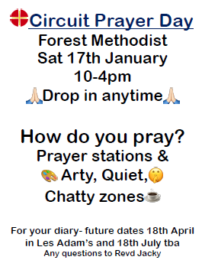

Corny Christmas Jokes!
Which of Santa’s reindeer has bad manners?
Rude-olph!
Who hides in a Christmas bakery?
A mince spy!
What falls but never gets hurt?
Snow!
Why do reindeer wear bells?
Because their horns don’t work!
Why are Christmas trees bad at sewing?
They always drop their needles!
What do you get if you cross a bell with a skunk?
Jingle smells!

Request from Michele
Does anyone know of someone who’d be coming from France to Guernsey after 18th December and would be prepared to being Bebe-Cat with them? An emergency evacuation brought on by P’s current health situation.

FUTURE DATE
SOUP AND CAKE LUNCH - Saturday 24th January

